모바일프로그래밍 과제07 컴퓨터소프트웨어공학과 2-YA 20202296 전채린

실습 6-1

[소스코드]

activity_main.xml

<?xml version="1.0" encoding="utf-8"?>  
<LinearLayout xmlns:android="http://schemas.android.com/apk/res/android"  
 xmlns:app="http://schemas.android.com/apk/res-auto"  
 xmlns:tools="http://schemas.android.com/tools"  
 android:layout_width="match_parent"  
 android:layout_height="match_parent"  
 android:orientation="vertical"  
 tools:context=".MainActivity">  
  
 /* 01 날짜와 시간 관련 위젯  
 실습6-1 날짜/시간 예약 앱 만들기 */  
 /*  
 타이머 기능: '예약 시간'과 '예약 완료'를 클릭하면 크로노미터가 타이머로 동작함  
 날짜/시간 설정: '날짜 설정', '시간 설정'을 클릭하면 예약 날짜와 시간을 변경할 수 있음  
 '예약 완료'를 클릭하면 설정한 날짜와 시간이 결정됨  
 */  
 /* 예제6-4 activity_main.xml */  
  
 <TextView  
 android:layout_width="match_parent"  
 android:layout_height="wrap_content"  
 android:text="20202296 전채린" />  
 <LinearLayout  
 android:layout_width="match_parent"  
 android:layout_height="wrap_content"  
 android:orientation="vertical">  
 <Chronometer  
 android:layout_width="match_parent"  
 android:layout_height="wrap_content"  
 android:id="@+id/chronometer1"  
 android:format="예약에 걸린 시간 %s"  
 android:gravity="center"  
 android:textSize="20dp" />  
 <Button  
 android:layout_width="match_parent"  
 android:layout_height="wrap_content"  
 android:id="@+id/btnStart"  
 android:text="예약 시작" />  
 </LinearLayout>  
 <RadioGroup  
 android:layout_width="match_parent"  
 android:layout_height="wrap_content" >  
 <RadioButton  
 android:layout_width="match_parent"  
 android:layout_height="wrap_content"  
 android:id="@+id/rdoCal"  
 android:text="날짜 설정(캘린더뷰)" />  
 <RadioButton  
 android:layout_width="match_parent"  
 android:layout_height="wrap_content"  
 android:id="@+id/rdoTime"  
 android:text="시간 설정" />  
 </RadioGroup>  
 <LinearLayout  
 android:layout_width="match_parent"  
 android:layout_height="wrap_content">  
 <FrameLayout  
 android:layout_width="match_parent"  
 android:layout_height="wrap_content" >  
 <CalendarView  
 android:layout_width="match_parent"  
 android:layout_height="wrap_content"  
 android:id="@+id/calenderView1"  
 android:showWeekNumber="false" />  
 <TimePicker  
 android:layout_width="match_parent"  
 android:layout_height="wrap_content"  
 android:id="@+id/timePicker1"  
 android:timePickerMode="spinner" />  
 </FrameLayout>  
 </LinearLayout>  
 <LinearLayout  
 android:layout_width="match_parent"  
 android:layout_height="wrap_content"  
 android:background="#CCCCCC"  
 android:orientation=" horizontal">  
 <Button  
 android:layout_width="wrap_content"  
 android:layout_height="wrap_content"  
 android:id="@+id/btnEnd"  
 android:text="예약완료" />  
 <TextView  
 android:layout_width="match_parent"  
 android:layout_height="wrap_content"  
 android:id="@+id/textView1"  
 android:text="" />  
 </LinearLayout>  
</LinearLayout>

MainActivity.kt

package aca.dongyang.project6_1  
  
import android.graphics.Color  
import androidx.appcompat.app.AppCompatActivity  
import android.os.Bundle  
import android.os.SystemClock  
import android.view.View  
import kotlinx.android.synthetic.main.activity_main.*  
  
class MainActivity : AppCompatActivity() {  
 /* 예제6-5 Kotlin 코드1 */  
 var selectYear : Int = 0  
 var selectMonth : Int = 0  
 var selectDayOfMonth : Int = 0  
  
 override fun onCreate(savedInstanceState: Bundle?) {  
 super.onCreate(savedInstanceState)  
 setContentView(R.layout.*activity_main*)  
 /* 예제6-6 Kotlin 코드2 */  
 *title* = "시간 예약"  
  
 timePicker1.*visibility* = View.*INVISIBLE* calenderView1.*visibility* = View.*INVISIBLE* /* 예제6-7 Kotlin 코드3 */  
 rdoCal.setOnClickListener **{** timePicker1.*visibility* = View.*INVISIBLE* calenderView1.*visibility* = View.*VISIBLE* **}** rdoTime.setOnClickListener **{** timePicker1.*visibility* = View.*VISIBLE* calenderView1.*visibility* = View.*INVISIBLE* **}** /* 예제6-8 Kotlin 코드4 */  
 btnStart.setOnClickListener **{** chronometer1.*base* = SystemClock.elapsedRealtime()  
 chronometer1.start()  
 chronometer1.setTextColor(Color.*RED*)  
 **}** btnEnd.setOnClickListener **{** chronometer1.stop()  
 chronometer1.setTextColor(Color.*BLUE*)  
  
 /* 예제6-9 Kotlin 코드5 */  
 textView1.*text* = "" + selectYear + "년" + selectMonth + "월" + selectDayOfMonth + "일" + timePicker1.*currentHour* + "시" + timePicker1.*currentMinute* + "분"  
 **}** calenderView1.setOnDateChangeListener **{** calendarView, i, i2, i3 **->** selectYear = i  
 selectMonth = i2 + 1  
 selectDayOfMonth = i3  
 **}** }  
}

[실행결과]

1) 초기화면

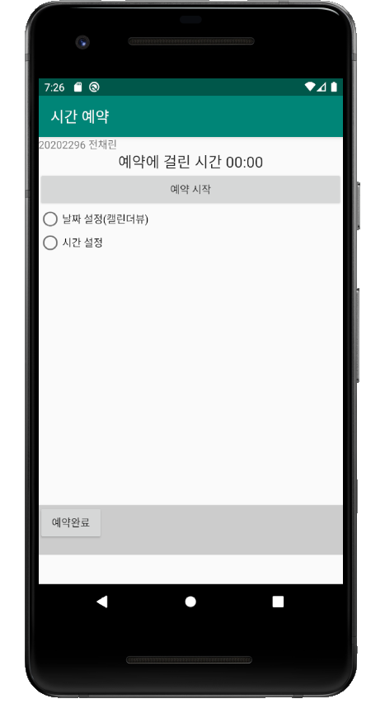

2) 날짜 설정 화면

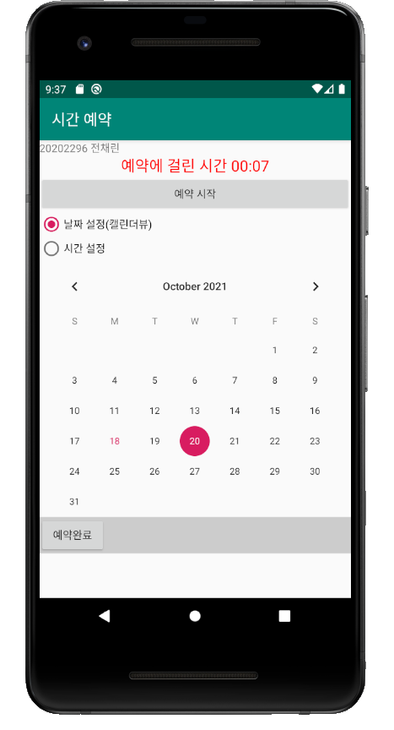

3) 시간 설정 화면

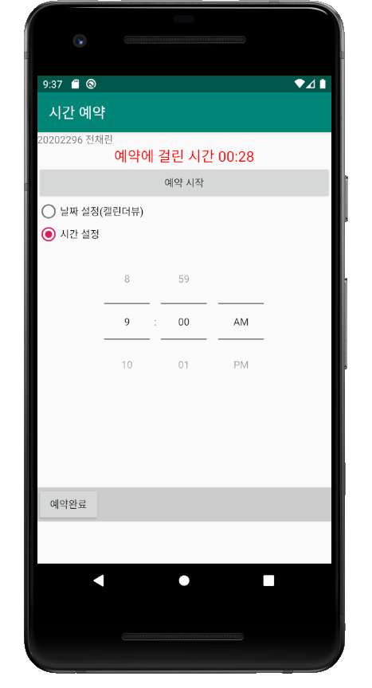

4) 예약완료 화면

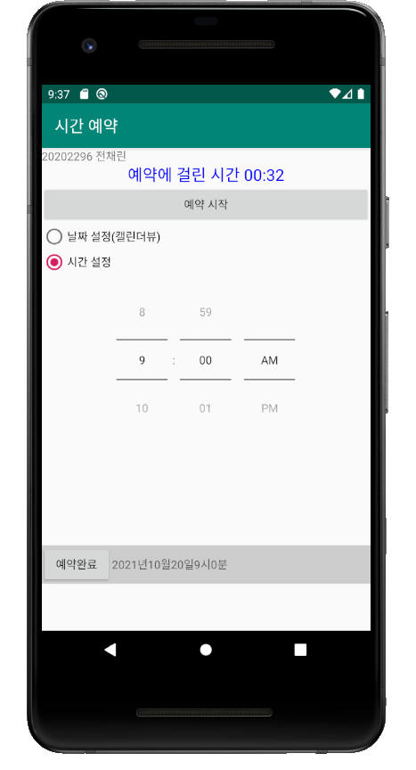

실습 6-2

[소스코드]

activity_main.xml

<?xml version="1.0" encoding="utf-8"?>  
<LinearLayout xmlns:android="http://schemas.android.com/apk/res/android"  
 xmlns:app="http://schemas.android.com/apk/res-auto"  
 xmlns:tools="http://schemas.android.com/tools"  
 android:layout_width="match_parent"  
 android:layout_height="match_parent"  
 android:orientation="vertical"  
 tools:context=".MainActivity">  
  
 /* 02 복잡한 기능의 뷰 컨테이너  
 실습6-2 간단 웹브라우저 만들기 */  
 /*  
 에디트텍스트에 URL을 입력하면 해당 링크로 이동하는 앱 만들기  
 화면의 로고와 프로그램의 아이콘도 변경하기  
 */  
 /* 예제6-22 activity_main.xml */  
  
 <LinearLayout  
 android:layout_width="wrap_content"  
 android:layout_height="wrap_content"  
 android:orientation="horizontal" >  
 <EditText  
 android:layout_width="match_parent"  
 android:layout_height="wrap_content"  
 android:id="@+id/edtUrl"  
 android:layout_weight="1"  
 android:singleLine="true"  
 android:hint="URL을 입력하세요." />  
 <Button  
 android:layout_width="match_parent"  
 android:layout_height="wrap_content"  
 android:id="@+id/btnGo"  
 android:text="이동" />  
 <Button  
 android:layout_width="match_parent"  
 android:layout_height="wrap_content"  
 android:id="@+id/btnBack"  
 android:text="이전" />  
 </LinearLayout>  
 <WebView  
 android:layout_width="wrap_content"  
 android:layout_height="match_parent"  
 android:id="@+id/webView1" />  
</LinearLayout>

MainActivity.kt

package aca.dongyang.project6_2  
  
import androidx.appcompat.app.AppCompatActivity  
import android.os.Bundle  
import android.webkit.WebResourceRequest  
import android.webkit.WebView  
import android.webkit.WebViewClient  
import kotlinx.android.synthetic.main.activity_main.*  
  
class MainActivity : AppCompatActivity() {  
  
 override fun onCreate(savedInstanceState: Bundle?) {  
 super.onCreate(savedInstanceState)  
 setContentView(R.layout.*activity_main*)  
  
 /* 예제6-27 Kotlin 코드4 */   
 webView1.*webViewClient* = CookWebViewClient()  
  
 var webSet = webView1.*settings* webSet.*builtInZoomControls* = true  
  
 btnGo.setOnClickListener **{** webView1.loadUrl(edtUrl.*text*.toString())  
 **}** btnBack.setOnClickListener **{** webView1.goBack()  
 **}** }  
}  
  
/* 예제6-25 Kotlin 코드2 */  
class CookWebViewClient : WebViewClient() {  
 /* 예제6-26 Kotlin 코드3 */  
 override fun shouldOverrideUrlLoading(view: WebView?, url: String?): Boolean {  
 return super.shouldOverrideUrlLoading(view, url)  
 }  
}

AndroidManifest.xml

<?xml version="1.0" encoding="utf-8"?>  
<manifest xmlns:android="http://schemas.android.com/apk/res/android"  
 package="aca.dongyang.project6_2">  
  
 /* 예제6-28 AndroidManifest.xml */  
 <uses-permission android:name="android.permission.INTERNET" />  
  
 <application  
 android:usesCleartextTraffic="true"  
 android:allowBackup="true"  
 android:icon="@mipmap/ic_launcher"  
 android:label="쿡북 웹브라우저"  
 android:roundIcon="@mipmap/ic_launcher_round"  
 android:supportsRtl="true"  
 android:theme="@style/AppTheme">  
 <activity  
 android:name=".MainActivity"  
 android:label="간단 웹브라우저" >  
 <intent-filter>  
 <action android:name="android.intent.action.MAIN" />  
  
 <category android:name="android.intent.category.LAUNCHER" />  
 </intent-filter>  
 </activity>  
 </application>  
  
</manifest>

[실행결과]

1) 초기화면

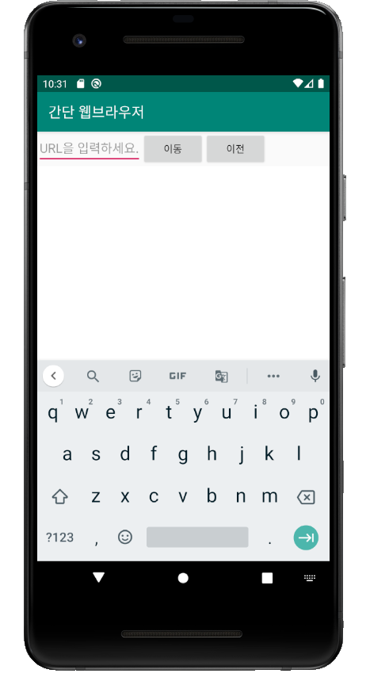

2) 다음 화면

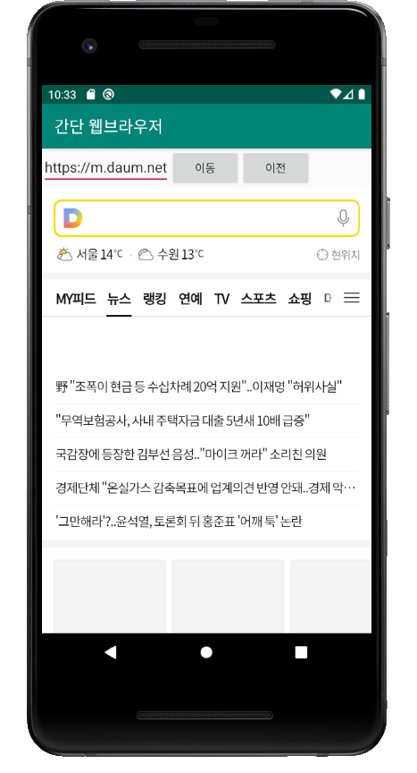

3) 네이버 화면

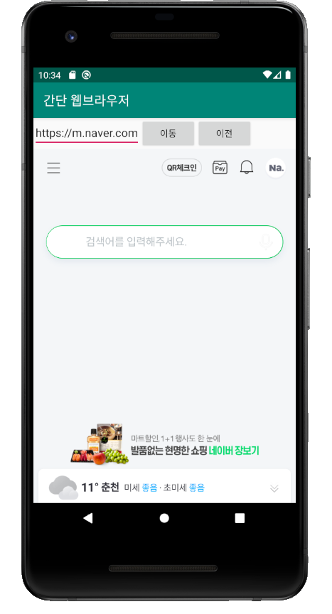

4) 이전 화면

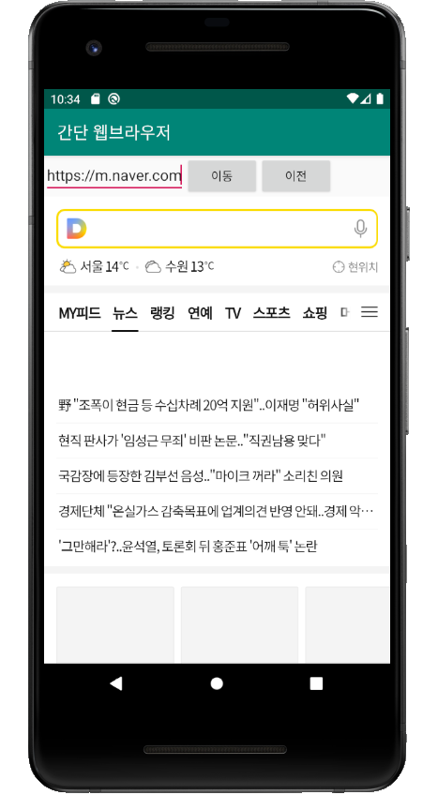

Test 6-1

[소스코드]

activity_main.xml

<?xml version="1.0" encoding="utf-8"?>  
<LinearLayout xmlns:android="http://schemas.android.com/apk/res/android"  
 xmlns:app="http://schemas.android.com/apk/res-auto"  
 xmlns:tools="http://schemas.android.com/tools"  
 android:layout_width="match_parent"  
 android:layout_height="match_parent"  
 android:orientation="vertical"  
 tools:context=".MainActivity">  
  
 /* 02 기타 위젯  
 Test6-1 */  
  
 <TextView  
 android:layout_width="match_parent"  
 android:layout_height="wrap_content"  
 android:id="@+id/textView"  
 android:layout_margin="30dp"  
 android:text="20202296 전채린" />  
 <SeekBar  
 android:layout_width="match_parent"  
 android:layout_height="wrap_content"  
 android:id="@+id/redBar"  
 android:layout_margin="10dp"  
 android:max="255"  
 android:progress="20" />  
 <TextView  
 android:layout_width="match_parent"  
 android:layout_height="wrap_content"  
 android:id="@+id/redText"  
 android:layout_margin="30dp"  
 android:text="red 값 : " />  
 <SeekBar  
 android:layout_width="match_parent"  
 android:layout_height="wrap_content"  
 android:id="@+id/greenBar"  
 android:layout_margin="10dp"  
 android:max="255"  
 android:progress="50" />  
 <TextView  
 android:layout_width="match_parent"  
 android:layout_height="wrap_content"  
 android:id="@+id/greenText"  
 android:layout_margin="30dp"  
 android:text="green 값 : " />  
 <SeekBar  
 android:layout_width="match_parent"  
 android:layout_height="wrap_content"  
 android:id="@+id/blueBar"  
 android:layout_margin="10dp"  
 android:max="255"  
 android:progress="125" />  
 <TextView  
 android:layout_width="match_parent"  
 android:layout_height="wrap_content"  
 android:id="@+id/blueText"  
 android:layout_margin="30dp" />  
 <Button  
 android:layout_width="match_parent"  
 android:layout_height="wrap_content"  
 android:id="@+id/btnOk"  
 android:text="확인" />  
 <TextView  
 android:layout_width="match_parent"  
 android:layout_height="wrap_content"  
 android:id="@+id/dpView"  
 android:text="" />  
</LinearLayout>

MainActivity.kt

package aca.dongyang.test6_1  
  
import android.graphics.Color  
import androidx.appcompat.app.AppCompatActivity  
import android.os.Bundle  
import android.widget.SeekBar  
import android.widget.Toast  
import kotlinx.android.synthetic.main.activity_main.*  
  
class MainActivity : AppCompatActivity() {  
  
 var red = 0  
 var green = 0  
 var blue = 0  
  
 override fun onCreate(savedInstanceState: Bundle?) {  
 super.onCreate(savedInstanceState)  
 setContentView(R.layout.*activity_main*)  
  
 red = redBar.*progress* green = greenBar.*progress* blue = blueBar.*progress* redText.*text* = "red 값 : " + red  
 greenText.*text* = "green 값 : " + green  
 blueText.*text* = "blue 값 : " + blue  
  
 var seekBarInstance = NoNameSeekBar()  
 redBar.setOnSeekBarChangeListener(seekBarInstance)  
  
 greenBar.setOnSeekBarChangeListener(object : SeekBar.OnSeekBarChangeListener {  
 override fun onProgressChanged(p0: SeekBar?, p1: Int, p2: Boolean) {  
 green = p1  
 greenText.*text* = "green 값 : " + green  
 }  
 override fun onStartTrackingTouch(p0: SeekBar?) {  
 }  
 override fun onStopTrackingTouch(p0: SeekBar?) {  
 }  
 })  
  
 blueBar.setOnSeekBarChangeListener(object : SeekBar.OnSeekBarChangeListener {  
 override fun onProgressChanged(p0: SeekBar?, p1: Int, p2: Boolean) {  
 blue = p1  
 blueText.*text* = "blue 값 : " + blue  
 }  
 override fun onStartTrackingTouch(p0: SeekBar?) {  
 }  
 override fun onStopTrackingTouch(p0: SeekBar?) {  
 }  
 })  
  
 btnOk.setOnClickListener **{** dpView.setBackgroundColor(Color.rgb(red, green, blue))  
 Toast.makeText(*applicationContext*, "버튼을 눌렀어요~~~~~~~~~~~~~~~`", Toast.*LENGTH_LONG*).show()  
 **}** }  
  
 // onCreat() End  
 inner class NoNameSeekBar : SeekBar.OnSeekBarChangeListener {  
 override fun onProgressChanged(p0: SeekBar?, p1: Int, p2: Boolean) {  
 red = p1  
 redText.*text* = "red 값 : " + red  
 }  
 override fun onStartTrackingTouch(p0: SeekBar?) {  
 }  
 override fun onStopTrackingTouch(p0: SeekBar?) {  
 }  
 }  
}

[실행결과]

1) 초기화면

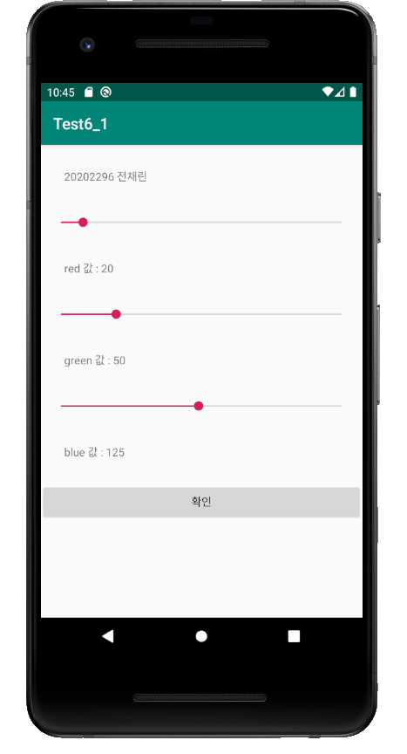

2) 결과 화면

